Week-9 (DAY-3) Hands-On
Contact Management & Category Management Microservices using API Gateway and Database per Service Pattern
Design and implement a Microservices-based Contact Management system by splitting a monolithic application into two independent microservices and exposing them through an API Gateway.
Each microservice must:
- Manage its own domain
- Maintain its own database (Database per Service)
- Be accessible via an API Gateway built using Ocelot
A company is modernizing its legacy monolithic Contact Management system.
To improve scalability and maintainability, they decide to:
- Break the application into independent microservices
- Introduce an API Gateway to act as a unified entry point for clients
- Ensure each service owns its data (Database per Service pattern)
As a first phase:
- Services will remain independent (no inter-service communication)
- All client requests will go through the API Gateway

Requirements:
🔹 Microservice 1: Contact Management Service
Functionalities:
- Add new contact
- Get all contacts
- Get contact by ID
- Update contact
- Delete contact
Contact Model:
- ContactId
- Name
- Email
- Phone
- CategoryId (reference only)
🔹 Microservice 2: Category Management Service
Functionalities:
- Add new category
- Get all categories
- Get category by ID
- Update category
- Delete category
Category Model:
- CategoryId
- CategoryName
- Description
🔹 API Gateway (MANDATORY ⭐)
Students must implement an API Gateway using:
👉 Ocelot
Responsibilities:
- Route incoming requests to appropriate microservices
- Provide a single entry point
/api/contacts → ContactService
/api/categories → CategoryService

🏗️ Architecture Diagram
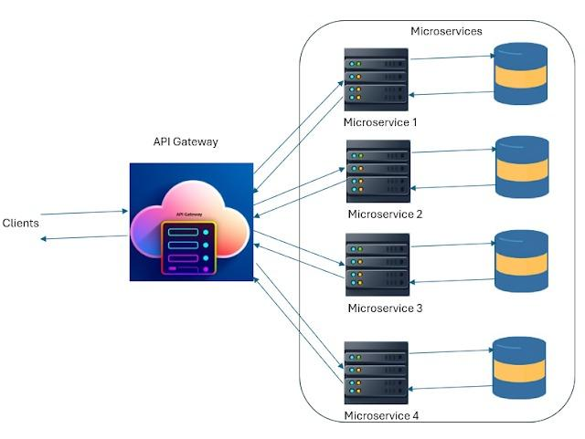
🔍 Explanation:
- Client sends request → API Gateway
- API Gateway routes request → respective service
- Each service interacts with its own database

🔹 Key Functional Rule ⭐
- CategoryId:
  - Only a reference field
  - ❌ No foreign key
  - ❌ No validation
  - ❌ No service-to-service communication

🔹 Database per Service Pattern
- Contact Service → ContactDB
- Category Service → CategoryDB
- No database sharing

⚙️ Technical Constraints
Use ASP.NET Core Web API (.NET 6 / .NET 8)
Implement API Gateway using Ocelot
Follow Layered Architecture:
- Controller Layer
- Service Layer
- Repository Layer
Use:
- Entity Framework Core OR Dapper
- SQL Server
🔹 Microservices Rules:
- Each microservice must:
  - Run on a different port
  - Be a separate project/solution
  - Have its own database

Expectations
- Proper implementation of:
  - Contact Service
  - Category Service
  - API Gateway (Ocelot)
- API Gateway should:
  - Successfully route requests
  - Hide internal service URLs
- Clean architecture and coding standards
- Proper Dependency Injection
- RESTful APIs with correct HTTP methods
- Swagger testing

✅ Demonstration:
Students must demonstrate:
- Access APIs via API Gateway ONLY
- Example:
  - GET /api/contacts via Gateway
  - GET /api/categories via Gateway
- Both services running independently
- Databases working separately

Learning Outcomes
After completing this hands-on, learners will:
- Understand Microservices Architecture fundamentals
- Learn how to:
  - Split a monolithic system into services
  - Implement Database per Service pattern
- Gain hands-on experience with:
  - API Gateway using Ocelot
  - Request routing in microservices
- Understand:
  - Role of API Gateway
  - Service independence
  - Deployment flexibility

